**Smoothies and Statistics: A Quality Blend**

**Submitted to:**

Dr. Jianbiao Pan, Professor

Industrial Mfg. and Engineering/California Polytechnic State University, SLO

San Luis Obispo, CA 93405

**Prepared by:**

Megan Dibble, Student

Sarah Smith, Student

Jasmine Henry, Student

Matt Zimmerman, Student

Industrial Mfg. and Engineering/California Polytechnic State University, SLO

San Luis Obispo, CA 93405

December 2, 2018

**Table of Contents**

**Executive Summary**2

**1.0 Improvement Opportunity: Define Phase**3

**2.0 Current State of the Process: Measure Phase**5

2.1 Identification of Key Variables 5

2.2 Identification of Target Performance Levels or Project Goals 5

2.3 Data Collection for Current Performance Level 5

**3.0 Analysis and Findings**6

**4.0 Recommendations: Improve Phase**9

4.1 Alternative Solutions Considered 9

4.2 Recommended Solution 10

**5.0 Monitoring and Control: Control Phase**10

**6.0 Conclusion**11

**Appendix**13

A1: Current State Data 13

A2: Post Improvement Data 16

# Executive Summary

Lucy’s is a dining facility located in the University Union on Cal Poly San Luis Obispo’s campus. They primarily provide smoothies and milkshakes to Cal Poly students, faculty, staff, and guests as a quick snack. The problem Lucy’s faces is the amount of excess smoothie remaining after an employee blends a smoothie and pours it in the cup to be served. Employees do not necessarily follow the recipe given, and therefore the variation in excess smoothie ranges greatly due to each operator straying from the recipe in their own way. Although we have only been investigating this issue for the past eight weeks, we believe this has been an ongoing problem that needs to be addressed to improve the quality of Lucy’s as a company and the quality of the customer experience at Lucy’s. This report addresses in greater detail the causes behind these variations, analysis on the data collected, and solutions to create a more consistent, tasty smoothie.

Our team used the DMAIC Six Sigma problem solving process to form a foundational understanding of the process, examine it through data, and seek opportunities for improvement in reducing variation as well as excess smoothie. We first observed Lucy’s employees to learn their procedure, and then we created a data collection plan. This was comprised of eight hour long periods, where we recorded the ounces of smoothie excess smoothie once the drinks were poured. This data allowed us to determine whether or not our key metrics were fulfilled.

A major finding in the project is that variation in excess smoothie results from not having standardized measuring tools. We implemented a solution of using standardized measuring scoops for solid ingredients rather than measuring by the handful. This update decreased waste by 42% but did not decrease variation which led us to conclude that the recipes may need to be re-evaluated.

Our analysis allowed us to see which smoothies were most frequently ordered and the smoothies that produced the most amount of leftovers. Combining this information, we recommended that if Lucy’s were to reexamine its recipes, they should begin with Glowing Greens, Mango Tango, Guava Berry, and Tropical Powerplay. These were the smoothies that were made most frequently and still had a relatively large amount of excess; therefore, changing these recipes would decrease the overall waste and variation.

# 

# 1.0 Improvement Opportunity: Define Phase

We began the define phase of the project with the intention of better understanding the current problem, determining ways to address it, and brainstorming how to fix it. This entailed clearly defining the problem and the key metrics, recording the operations of the business, and displaying that information through different visual methods and quality tools.

The main problem we found revolves around the amount of excess smoothie left in a blender after pouring the substance into a cup to be given to the customer. Having the excess smoothie go to waste is an efficiency problem in itself, but we chose to acknowledge the Six Sigma portion by examining the variation in the amount left over. We shortly discovered that this variation comes from employees not following the recipes, but instead, making a smoothie with adjustments to fit what they deem to be a “good” smoothie. Naturally, this leads to a large variation in excess smoothie due to several different employees making the same smoothie each in their own way. In preparation of data collection, we decided to examine the problem using two main key metrics:

1. Amount of smoothie left over (in ounces)
2. First pass yield

Collecting the number of ounces left over in a blender gave us hard quantitative data on the amount of waste and how consistent the waste would occur in order to analyze our results later. Secondly, we wanted to observe the first pass yield because knowing how often a smoothie has to be reblended is indicative of the variation stemming from either the recipes, the employee who makes the smoothie, or both. Additionally, this increases the service time because the employee wasn’t able to make the proper smoothie the first time. It is displeasing to the customer that they must wait longer and frustrating to the employees that they must redo a task.

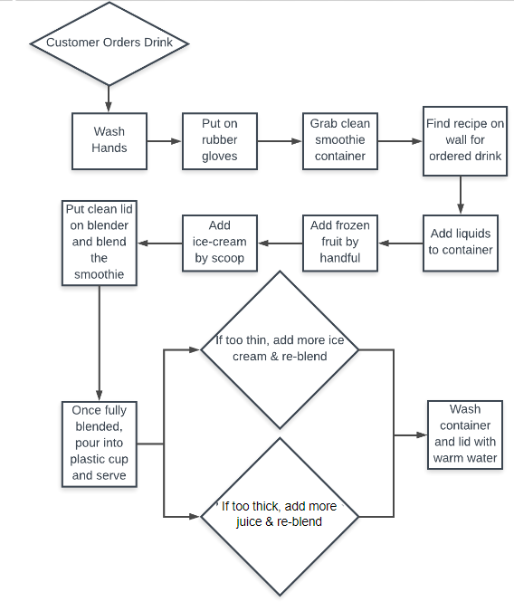

To gain perspective and initial thoughts, we observed the operations of Lucy’s through the employee’s actions. We made a process flow chart after recording their steps seen in Figure 1. To make a smoothie, the process is started by taking the customer’s orders. Then, the employee washes their hands, puts on gloves, and grabs a clean smoothie container. At that point, if they don’t have the recipe memorized, they look at the recipe posted on the wall, and start to make the smoothie by adding the liquids to the container, followed by frozen fruit and ice cream, respectively. Afterwards, a lid is placed on the blender, and it goes onto the blending machine. Once it is fully blended, they pour it into a plastic cup and serve it. The employees have the option to reblend the drink after they begin pouring if they believe it to be too thin or too thick. Figure 1: Lucy’s Process Flow Chart

We immediately noticed some major issues: adding fruit by the handful and no specifications on recipe measurements. Every employee has different sized hands, so it seems obvious that there could potentially be a large discrepancy in excess smoothie due to hand size differences. Furthermore, a recipe might say, for example, “one scoop” of ice cream for a particular smoothie, but it doesn’t specify if that is “one overflowing scoop” or “one leveled off scoop.” Beyond the issues within the process itself, we also realized that they only had one recipe posted for two different sizes of smoothies - regulars and combos. Combos are 12 ounce cups that are specifically for customers who order sandwiches from Poly Deli with a smoothie as opposed to just ordering a “regular” 20 ounce smoothie from Lucy’s front counter. This implies that there is no standard operating procedure for making a combo smoothie, so employees are putting the same amount of each ingredient for two smoothies that have a relatively large size difference.

We gained further insight when talking to the employees and the manager about the company. We gathered enough information to complete a SIPOC diagram, shown in Figure 2 below.

|  |  |  |  |  |
| --- | --- | --- | --- | --- |
| **Suppliers** | **Inputs** | **Process** | **Outputs** | **Customers** |
| Sysco | Ice cream | 1. Take order on cash register | Blended smoothies | College students |
| Unify | Frozen fruit | 2. Wash hands and put on gloves | Milkshakes | Campus guests |
| Coke | Bee pollen & chia seeds | 3. Dispense liquid for recipe | Wheatgrass shots | Faculty |
| Amazon | Juices | 4. Add frozen fruit, ice cream, or other add ins according to recipe |  | Staff |
|  | Produce (Spinach, kale, bananas, etc) | 5. Blend smoothie |  |  |
|  | Granola | 6. Pour and serve smoothie |  |  |
|  | Cookies | 7. If needed, pour smoothie back into blender and add additional ingredients |  |  |
|  | Peanut butter |  |  |  |

Figure 2: Lucy’s SIPOC Diagram

This chart allows us to see the entire lifecycle of the smoothie and catch possible areas of improvement outside of the process itself. For example, it could be helpful to look at the ingredients going into the smoothies, not just how the smoothie is made.

The scope of the project includes improving the quality of smoothies and milkshakes. It excludes juices and wheatgrass shots. This is because of the time and resource constraints brought on by other important obligations and the date of completion.

# 2.0 Current State of the Process: Measure Phase

## 2.1 Identification of Key Variables

From our initial Lucy’s visit, a key finding was that the employees aren’t following the ingredient quantities designated in the smoothie recipes. Instead, each employee is determining what he or she thinks constitutes a good recipe. Because of this, smoothies are inconsistent. When the same type of smoothie is made by different employees, they have varying thickness. There are varying amounts of excess smoothie leftover once it is poured from the blender to the serving cup. From a production viewpoint, this means there are varying levels of scrap or waste. Our team identified the excess smoothie as a key variable towards improving the quality of Lucy’s smoothies and milkshakes.

Another problem we found is that occasionally when smoothies are poured from the blender to the cup, the smoothie doesn’t initially reach the cup fill line. When this occurs, the employee has to pour the smoothie back into the blender and add more ingredients. They reblend and then pour back into the cup. From these observations, we determined that another key metric is the first pass yield. We will analyze the percent of smoothies that do not need to be reblended.

Summary of key metrics:

1. Excess smoothie

2. First pass yield

## 2.2 Identification of Target Performance Levels or Project Goals

We acknowledge that the goal of the project is to decrease variation, as it is a Six Sigma project, but we would like to do so while also decreasing the amount of waste produced. In other words, we would like there to be minimal variation from zero ounces of leftover smoothie. This is why we started by decreasing the range in order to decrease the variation. From there, it is easier to make the smoothies more accurate with zero leftover ounces of smoothie.

We will analyze the excess leftovers from smoothies and milkshakes as well as aim to reduce variation in smoothie quality. We will measure this by measuring the mean excess smoothie and the range of excess smoothie for each type of smoothie and try to reduce each metric.

## 2.3 Data Collection for Current Performance Level

To fully understand the current state, we collected data at Lucy’s during normal operating hours. The manager requested that we didn’t observe during the peak demand times (from 11 am-2 pm) because she didn’t want us to disrupt production and slow down the employees. To respect her request, we observed production from 10-11 am and from 2-3 pm.

For two weeks we had a team member observing smoothie production twice a day, and we recorded data from the first 8 smoothies being made during each shift. We used this rational subgroup data collection method because we originally thought we would analyze our data using a control chart. Once we began our data collection, we realized that a control chart wouldn’t be the best option for analysis since the data wasn’t normal and we didn’t want large amounts of excess smoothie to be considered an “in control” amount.

The data we collected included the amount of excess smoothie (in ounces), the type of smoothie being blended, which smoothie size was being served (regular or combo size), and any comments about the smoothie being made.

To collect data on excess smoothie, we asked the employees to pour the excess into a measuring cup that had ounces labelled on the side. We used the measuring cup to determine excess instead of the blender so that the employee could quickly rinse the blender and begin making the next smoothie order.

Our data collection method had some concerns. The first was that it was impossible for the employees to transfer every drop of excess smoothie into the measuring cup. Some employees tried harder than others to get as much into the measuring cup as possible. Some employees mentioned that they would try to have less excess because they knew we were observing them. This indicates that our data may not have been a perfect representation of the current state. Another observation was that some smoothies were being poured into the regular size cups (20 oz.), while others were poured into the combo size (16 oz.). This may have affected the amount of excess smoothie. Employees occasionally made multiple combos, multiple regulars, or a combination of the two, which also affected the amount of excess smoothie.

Our current state data can be found in Appendix A1.

# 3.0 Analysis and Findings

After observerving considerable variability in Lucy’s smoothie process, we created a fishbone diagram to examine at possible sources of variation (see figure 3 below). We narrowed down our focus by determining what was feasible to target and what we received feedback on from employees.

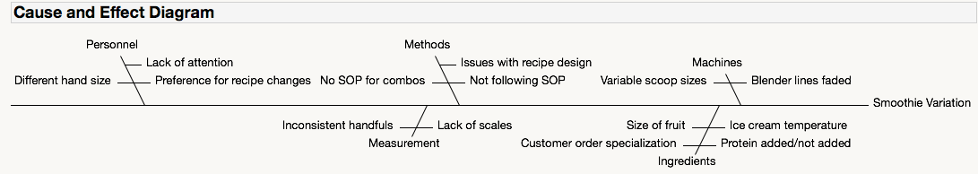

Figure 3: Lucy’s Cause and Effect Diagram

A consistent piece of feedback was that the recipes for the smoothies were not designed properly to ensure the correct amount of smoothie. What we found unclear was whether this was the root problem, causing employees to alter the recipes in their own way, thus creating variability, or whether the variability was caused by lack of standardized measuring tools to allow for following the recipe correctly.

In the event that the recipes need to be changed, we created Pareto charts to analyze which smoothies were the most popular (see figure 4). Because changing the recipes would require significant effort on Lucy’s behalf, we recommend that they target the four highlighted smoothies to be able to target approximately 80% of the variation.

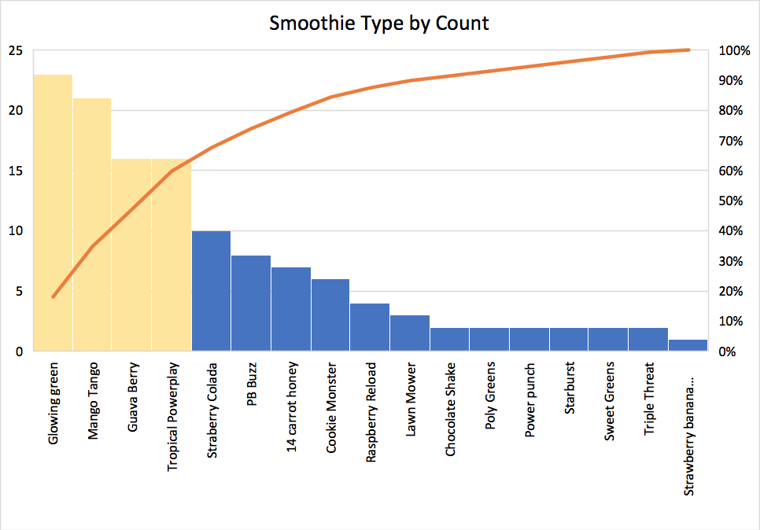

Figure 4: Pareto of Smoothie Type by Count

We also examined the range of values of excess smoothie for all smoothies observed because it is possible that only some recipes are flawed. This comparison can be seen in the second Pareto chart (see figure 5). It was clear that the most popular smoothies also ranked among the most variable smoothies, confirming the suggestion of narrowing focus to the top four selling smoothies. We chose not to focus on the Chocolate Shake and Strawberry Colada smoothie because even though they had the highest range, they were some of the least ordered drinks and therefore our efforts would not be very impactful.

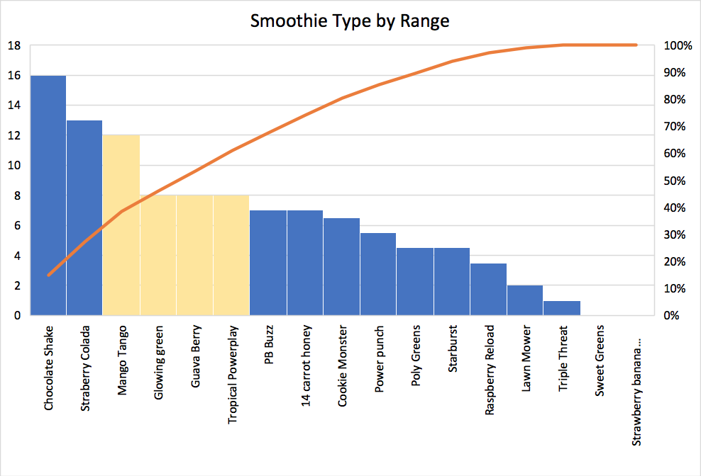

Figure 5: Pareto of Smoothie Type by Range

Another metric that we wanted to analyze was first pass yield. Any smoothie that had to be reblended was considered non-conforming. From the 128 current state data points, the first pass yield percentage was 89.8%.

After observing the process, we also found that some smoothies were a part of a combo deal, which included a 12 oz smoothie (instead of 20 oz). We thought that this might be significant and increase the amount of variability since there are no customized recipes for combo smoothies. The one-way ANOVA test below (figure 6) illustrates that there was in fact no statistical difference in smoothie excess between the combo and regular smoothie types.

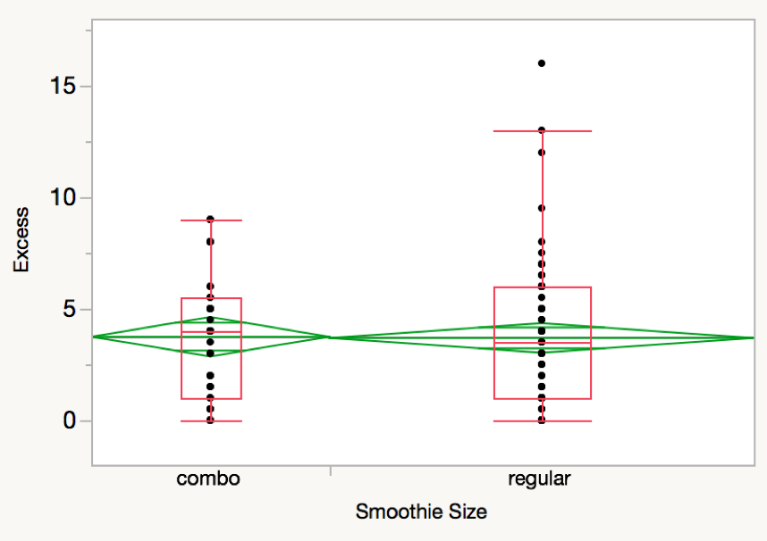

Figure 6: One-way ANOVA test of Combo vs. Regular Smoothie Size

In order to improve the first pass yield percentage and decrease the variation in smoothie excess we decided to pursue standardizing the measuring cups, and the results of this will be discussed in the following section of the report.

We pivoted in our analysis a bit and did not construct a control chart for the current state data because ideally the excess smoothie amount would be zero, so it does not make sense to set upper and lower specification limits and analyze capability.

# 4.0 Recommendations: Improve Phase

In the improve phase, we continued to use our key metrics to drive the alternative solutions that we considered. The first and more important metric is the amount of smoothie left in the blender after filling the smoothie cup. This excess smoothie is wasted product and added cost, and our solutions will be focused on reducing this smoothie excess as much as possible while still keeping the process stable. The second metric of this project is the first pass yield-- or the percentage of smoothies that are made right the first time. Smoothies that need to be re-blended not only take longer to make and increase customer wait time, but they are an avoidable waste of employees’ time. That being said, there were a handful of solutions that were considered.

## 4.1 Alternative Solutions Considered

To improve Lucy’s smoothie manufacturing process, the first alternative solution was to provide more training to both new and seasoned employees on the recipes that are posted in the kitchen. This training would allow the employees to make each smoothie on the menu using the recommended recipes. This solution would require Lucy’s to hold a paid training for all of its employees, which would cost a significant amount of money. Further, this training would also have a resource cost associated with the resources required for the employees to make these practice smoothies.

The next solution that was considered involved a standardization process that any employee could follow and would ensure that no matter the operator, the same smoothie would be produced. The recipes that Lucy’s currently use contain quantities in ounces for all ingredients, and there are no measuring cups for employees to use for these solid items such as frozen fruit and bananas. For this reason, many employees add ingredients by the handful to the smoothie. Seasoned employees have these recipes memorized, and they know how much to add in order to produce a smoothie that is the right consistency and fills the cup to the brim. However, because each employees experience affects how he or she makes a smoothie, there is significant variability in smoothie excess. An example of this would be when one employee knows to add two handfuls of frozen mangos to a Mango Tango smoothie though the recipe only calls for 5 ounces of mangos, because this employee knows that only one handful would not produce enough smoothie to fill a standard sixteen ounce cup. Our solution to this problem is to provide the correct measuring cups so that employees can correctly follow the recipes when making smoothies. This solution’s success depends on every employee following the recipes exactly in order to ensure that operator error will not factor into the quality of smoothies being produced.

After observing the smoothie making process for two weeks, we did not want to redesign the process flow, because we do not think there is anything wrong with the flow of materials during the manufacturing process for Lucy’s. Redesigning the process flow would also not directly relate to the metrics that we are using for our project. If we were doing time studies on the manufacturing process, a process flow redesign could be beneficial to reducing the overall production time. However, this was not in our project scope.

## 4.2 Recommended Solution

Once all of the alternatives were weighed, our recommended solution was solution number two--standardizing the measuring system used when following smoothie recipes. We chose this solution for a few reasons. The first reason was that it was the cheaper solution by far. The first solution would cost Lucy’s hundreds of dollars in cost associated with training, while the second solution is virtually free. Since Lucy’s uses cookware from the neighboring restaurant, getting proper measuring cups would not cost Lucy’s anything. Also, because of the time constraint for our project, this solution was feasible to implement and record data in just a few short weeks. The only thing that Lucy’s management needs to do for this solution is place out the proper measuring tools so that the employees can use those tools to follow the recipes when fulfilling smoothie orders. Once that is done, it is up to us to continue to record data to see whether or not that solution worked to reduce variability in the manufacturing process.

# 5.0 Monitoring and Control: Control Phase

Once the recommended solution was discussed with Lucy’s management, we moved onto the control phase of our project. The independent variable that we are controlling for this stage is the measuring system that Lucy’s employees use when producing smoothies. To standardize the measurement system, Lucy’s will be using measuring cups instead of nothing at all--which is how they were initially doing it. By controlling this aspect of the manufacturing process, we hoped to reduce the variability in the process. Additionally, to ensure the accuracy of the data collected during the control phase in comparison with our initial phase, we collected data during the same days and during the same times and with the same operators to reduce assignable cause variation within our data. Figure 7 below shows the One-way ANOVA analysis that was performed to determine whether or not the change in sample means from before and after the control phase. At a 90% level of confidence, the difference in means is statistically significant. The initial sample mean (in ounces) of excess smoothie was about 4 ounces of excess per smoothie. After the control phase, the new sample mean was reduced to 2.31 ounces per smoothie--roughly a 42% decrease (Table 1).

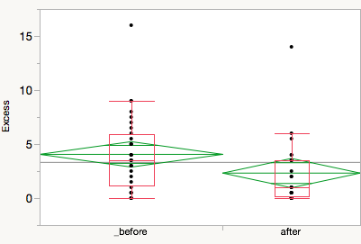

Figure 7: One-way ANOVA Box Plot for Smoothie Excess

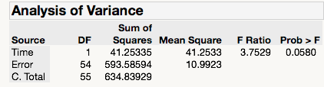

Table 1: Analysis of Variance between ‘“Before” and “After” Means

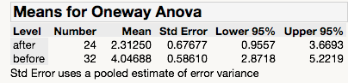

Table 2: One-way ANOVA “Before” and “After” Means

Though the sample mean was reduced after the control phase, the standard deviation between smoothies increased slightly from 0.586 to 0.676 (Table 2). This did not worry us, however, because our sample size was smaller during the control phase due to the time constraint on this project. Furthermore, the variability between smoothies was not explicitly defined as a metric for this project. Our first priority was reducing the waste per smoothie, and we were able to achieve that. If we had more time, we would like to continue to record data during the control phase to see if the standard deviation is actually larger than during the initial phase of this project.

The second metric that was measured during the control phase was the first pass yield percentage. In the initial stage before we attempted to standardize the production process, the first pass yield percentage was 89.8%. After the control phase, the first pass yield went down to 79.2%. A lower first pass yield is not desirable because it suggests more re-work needs to be done to the smoothies, resulting in longer customer wait times and wasted operator time. Data collected during the control phase can be found in the Appendix under section A2.

# 6.0 Conclusion

The goals of this project were to reduce excess smoothie thrown away and improve first pass yield. In order to achieve these goals, we defined the process, extensively observed the process and collected data, analyzed the current state and root causes of issues, and implemented our solution: standardized measuring scoops. The first goal of the project was accomplished, while the second was not. The implementation of the measuring scoops decreased the waste in the process by 42%, so we see benefit in Lucy’s continuing to use our solution. Based on these metrics and feedback we received, we believe there is still room for improvement at Lucy’s.

In particular, seeing first pass yield decrease can most likely be attributed to the smoothie recipes not being designed correctly to produce 20 oz of smoothie. Employees had to add some ingredients incrementally and re-blend even though they correctly followed the recipes and used standardized measuring tools. Based on this finding, we suggest that Lucy’s re-evaluate their recipes. Now that they have more standardized measuring tools, if the managers create recipes using the tools, and employees are informed and trained to follow the recipes, the business should see further reduction of waste, variability, and increased first pass yield.

# Appendix

## A1: Current State Data

|  |  |  |  |  |  |
| --- | --- | --- | --- | --- | --- |
| **Date** | **Time** | **Excess (oz)** | **Smoothie Type** | **Smoothie Size** | **Reblend?** |
| Monday 10/22 | 10-11 | 4.0 | Mango Tango | combo | 0 |
| Monday 10/22 | 10-11 | 6.0 | Mango Tango | combo | 0 |
| Monday 10/22 | 10-11 | 13.0 | Strawberry Colada | regular | 1 |
| Monday 10/22 | 10-11 | 3.0 | Raspberry Reload | regular | 0 |
| Monday 10/22 | 10-11 | 2.0 | Glowing Greens | combo | 0 |
| Monday 10/22 | 10-11 | 5.0 | Tropical Powerplay | combo | 0 |
| Monday 10/22 | 10-11 | 1.5 | Power Punch | regular | 0 |
| Monday 10/22 | 10-11 | 3.5 | Mango Tango | combo | 0 |
| Monday 10/22 | 2-3 | 1.0 | Glowing Greens w/honey | combo | 0 |
| Monday 10/22 | 2-3 | 4.0 | Peanut Butter Buzz | regular | 0 |
| Monday 10/22 | 2-3 | 3.0 | Poly Greens | regular | 0 |
| Monday 10/22 | 2-3 | 5.5 | Guava Berry | regular | 0 |
| Monday 10/22 | 2-3 | 2.5 | Strawberry Colada | regular | 0 |
| Monday 10/22 | 2-3 | 0.5 | Glowing Greens | combo | 0 |
| Monday 10/22 | 2-3 | 9.0 | Mango Tango | combo | 0 |
| Monday 10/22 | 2-3 | 0.5 | Tropical Powerplay | combo | 0 |
| Tuesday 10/23 | 10-11 | 0 | 14 Carrot Honey | regular | 0 |
| Tuesday 10/23 | 10-11 | 1 | Mango Tango | combo | 0 |
| Tuesday 10/23 | 10-11 | 0 | Guava Berry | regular | 0 |
| Tuesday 10/23 | 10-11 | 6 | Mango Tango | regular | 0 |
| Tuesday 10/23 | 10-11 | 0 | Glowing Greens | combo | 1 |
| Tuesday 10/23 | 10-11 | 2.5 | Raspberry Reload | regular | 0 |
| Tuesday 10/23 | 10-11 | 4 | Tropical Powerplay | combo | 0 |
| Tuesday 10/23 | 10-11 | 0 | Mango Tango | combo | 1 |
| Tuesday 10/23 | 2-3 | 1 | Guava Berry | regular | 0 |
| Tuesday 10/23 | 2-3 | 0 | Strawberry Colada | regular | 0 |
| Tuesday 10/23 | 2-3 | 2 | Mango Tango | combo | 0 |
| Tuesday 10/23 | 2-3 | 1 | Peanut Butter Buzz | regular | 0 |
| Tuesday 10/23 | 2-3 | 0.5 | Tropical Powerplay | combo | 0 |
| Tuesday 10/23 | 2-3 | 7 | Lawn Mower | regular | 0 |
| Tuesday 10/23 | 2-3 | 6.5 | Guava Berry | regular | 0 |
| Tuesday 10/23 | 2-3 | 0.5 | Strawberry Colada | regular | 0 |
| Wednesday 10/24 | 10-11 | 5 | Lawn Mower | regular | 0 |
| Wednesday 10/24 | 10-11 | 0 | 14 Carrot Honey | regular | 0 |
| Wednesday 10/24 | 10-11 | 3 | Cookie Monster | regular | 0 |
| Wednesday 10/24 | 10-11 | 4.5 | Glowing Greens | regular | 1 |
| Wednesday 10/24 | 10-11 | 3.5 | Guava Berry | regular | 0 |
| Wednesday 10/24 | 10-11 | 6 | 14 Carrot Honey | regular | 0 |
| Wednesday 10/24 | 10-11 | 5 | Mango Tango | combo | 0 |
| Wednesday 10/24 | 10-11 | 2.5 | Peanut Butter Buzz | regular | 0 |
| Wednesday 10/24 | 2-3 | 1.5 | Cookie Monster | regular | 0 |
| Wednesday 10/24 | 2-3 | 4.5 | Glowing Greens | combo | 0 |
| Wednesday 10/24 | 2-3 | 1 | Guava Berry | regular | 0 |
| Wednesday 10/24 | 2-3 | 3.5 | Cookie Monster | regular | 0 |
| Wednesday 10/24 | 2-3 | 2 | Tropical Powerplay | combo | 0 |
| Wednesday 10/24 | 2-3 | 1.5 | Mango Tango | combo | 0 |
| Wednesday 10/24 | 2-3 | 6 | Tropical Powerplay | combo | 0 |
| Wednesday 10/24 | 2-3 | 4 | Tropical Powerplay | combo | 0 |
| Thursday 10/25 | 10-11 | 4 | Glowing Greens | combo | 0 |
| Thursday 10/25 | 10-11 | 6 | Starburst | regular | 0 |
| Thursday 10/25 | 10-11 | 9.5 | Strawberry colada | regular | 0 |
| Thursday 10/25 | 10-11 | 6 | Glowing green | regular | 0 |
| Thursday 10/25 | 10-11 | 5.5 | Tropical Powerplay | combo | 0 |
| Thursday 10/25 | 10-11 | 6.5 | Cookie Monster | regular | 0 |
| Thursday 10/25 | 10-11 | 8 | Guava Berry | regular | 0 |
| Thursday 10/25 | 10-11 | 1 | Tropical Powerplay | regular | 0 |
| Thursday 10/25 | 2-3 | 5 | Mango Tango | combo | 1 |
| Thursday 10/25 | 2-3 | 0 | Peanut Butter Buzz | regular | 0 |
| Thursday 10/25 | 2-3 | 0 | Raspberry Reload | regular | 1 |
| Thursday 10/25 | 2-3 | 0 | Strawberry Colada | regular | 0 |
| Thursday 10/25 | 2-3 | 1.5 | 14 Carrot Honey | regular | 0 |
| Thursday 10/25 | 2-3 | 2 | Glowing Greens | regular | 0 |
| Thursday 10/25 | 2-3 | 6 | Strawberry Colada | regular | 0 |
| Thursday 10/25 | 2-3 | 4.5 | Guava Berry | regular | 0 |
| Monday 10/29 | 10-11 | 4 | Glowing Greens | regular | 0 |
| Monday 10/29 | 10-11 | 0.5 | Tropical Powerplay | regular | 0 |
| Monday 10/29 | 10-11 | 3 | Glowing Greens | regular | 0 |
| Monday 10/29 | 10-11 | 8 | Cookie Monster | combo | 0 |
| Monday 10/29 | 10-11 | 8 | Mango Tango | combo | 0 |
| Monday 10/29 | 10-11 | 4 | Guava Berry | regular | 0 |
| Monday 10/29 | 10-11 | 12 | Mango Tango | regular | 0 |
| Monday 10/29 | 10-11 | 1.5 | Glowing Greens | combo | 0 |
| Monday 10/29 | 2-3 | 8 | Tropical Powerplay | combo | 0 |
| Monday 10/29 | 2-3 | 4 | Tropical Powerplay | regular | 0 |
| Monday 10/29 | 2-3 | 1 | Guava Berry | regular | 0 |
| Monday 10/29 | 2-3 | 1 | Guava Berry | regular | 0 |
| Monday 10/29 | 2-3 | 6 | PB Buzz | regular | 1 |
| Monday 10/29 | 2-3 | 4.5 | Guava Berry | regular | 0 |
| Monday 10/29 | 2-3 | 4 | Glowing Greens | combo | 0 |
| Monday 10/29 | 2-3 | 7 | 14 Carrot Honey | regular | 0 |
| Tuesday 10/30 | 10-11 | 1 | Strawberry Colada | regular | 0 |
| Tuesday 10/30 | 10-11 | 0 | Glowing Greens | combo | 0 |
| Tuesday 10/30 | 10-11 | 5 | Triple Threat | regular | 0 |
| Tuesday 10/30 | 10-11 | 7 | PB Buzz | regular | 0 |
| Tuesday 10/30 | 10-11 | 1.5 | Glowing Greens | regular | 0 |
| Tuesday 10/30 | 10-11 | 0 | Strawberry Colada | regular | 1 |
| Tuesday 10/30 | 10-11 | 8 | Glowing Greens | combo | 1 |
| Tuesday 10/30 | 10-11 | 1 | Mango Tango | regular | 0 |
| Tuesday 10/30 | 2-3 | 1.5 | Glowing Greens | combo | 0 |
| Tuesday 10/30 | 2-3 | 6 | Tropical Powerplay | regular | 0 |
| Tuesday 10/30 | 2-3 | 0 | Chocolate Shake | regular | 0 |
| Tuesday 10/30 | 2-3 | 4 | Mango Tango | combo | 0 |
| Tuesday 10/30 | 2-3 | 3 | Mango Tango | combo | 0 |
| Tuesday 10/30 | 2-3 | 6 | Guava Berry | regular | 0 |
| Tuesday 10/30 | 2-3 | 5 | PB Buzz | regular | 1 |
| Tuesday 10/30 | 2-3 | 4 | Glowing Greens | combo | 0 |
| Wednesday 10/31 | 10-11 | 0 | Glowing Greens | regular | 1 |
| Wednesday 10/31 | 10-11 | 6.5 | Lawn Mower | regular | 0 |
| Wednesday 10/31 | 10-11 | 0.5 | Tropical Powerplay | regular | 0 |
| Wednesday 10/31 | 10-11 | 4 | Triple Threat | regular | 1 |
| Wednesday 10/31 | 10-11 | 9 | Mango Tango | combo | 0 |
| Wednesday 10/31 | 10-11 | 8 | Cookie Monster | combo | 0 |
| Wednesday 10/31 | 10-11 | 5.5 | Tropical Powerplay | combo | 0 |
| Wednesday 10/31 | 10-11 | 16 | Chocolate Shake | regular | 0 |
| Wednesday 10/31 | 2-3 | 7 | Power punch | regular | 0 |
| Wednesday 10/31 | 2-3 | 3.5 | Guava Berry | regular | 0 |
| Wednesday 10/31 | 2-3 | 5 | Strawberry banana milkshake | regular | 0 |
| Wednesday 10/31 | 2-3 | 3 | Mango Tango | combo | 0 |
| Wednesday 10/31 | 2-3 | 9 | Mango Tango | combo | 0 |
| Wednesday 10/31 | 2-3 | 0 | Tropical Powerplay | combo | 0 |
| Wednesday 10/31 | 2-3 | 0 | Mango Tango | combo | 0 |
| Wednesday 10/31 | 2-3 | 5 | Glowing Greens | combo | 0 |
| Thursday 11/1 | 10-11 | 3.5 | Strawberry Colada | regular | 0 |
| Thursday 11/1 | 10-11 | 5 | Glowing greens | combo | 0 |
| Thursday 11/1 | 10-11 | 2 | 14 Carrot Honey | regular | 0 |
| Thursday 11/1 | 10-11 | 4 | Sweet Greens | regular | 0 |
| Thursday 11/1 | 10-11 | 1.5 | Starburst | regular | 0 |
| Thursday 11/1 | 10-11 | 4 | Sweet Greens | regular | 0 |
| Thursday 11/1 | 10-11 | 6 | Guava Berry | regular | 0 |
| Thursday 11/1 | 10-11 | 2.5 | Glowing greens | regular | 0 |
| Thursday 11/1 | 2-3 | 7.5 | Poly Greens | regular | 0 |
| Thursday 11/1 | 2-3 | 0.5 | Glowing Greens | combo | 0 |
| Thursday 11/1 | 2-3 | 1 | Guava Berry | regular | 1 |
| Thursday 11/1 | 2-3 | 3 | PB Buzz | regular | 0 |
| Thursday 11/1 | 2-3 | 0 | 14 Carrot Honey | regular | 0 |
| Thursday 11/1 | 2-3 | 3 | Mango Tango | regular | 0 |
| Thursday 11/1 | 2-3 | 3.5 | Raspberry Reload | regular | 0 |
| Thursday 11/1 | 2-3 | 0.5 | Glowing Greens | combo | 0 |

## A2: Post Improvement Data

|  |  |  |  |  |  |
| --- | --- | --- | --- | --- | --- |
| **Date** | **Time** | **Excess (oz)** | **Smoothie type** | **Smoothie Size** | **Reblend?** |
| Wednesday 11/14 | 2-3 pm | 0 | Glowing Greens | regular | 1 |
| Wednesday 11/14 | 3-4pm | 3.5 | Cookie Monster | regular | 0 |
| Wednesday 11/14 | 3-4pm | 14 | Sweet Greens | regular | 0 |
| Wednesday 11/14 | 3-4pm | 0 | Glowing Greens | regular | 0 |
| Wednesday 11/14 | 3-4pm | 0 | Strawberry Colada | regular | 0 |
| Wednesday 11/14 | 3-4pm | 0 | Glowing Greens | combo | 0 |
| Wednesday 11/14 | 3-4pm | 1 | PB Buzz | regular | 0 |
| Wednesday 11/14 | 3-4pm | 0.5 | Guava Berry | regular | 0 |
| Wednesday 11/14 | 3-4pm | 4 | Guava Berry | regular | 0 |
| Thursday 11/15 | 10-11am | 6 | Pineapple Pointguard | regular | 1 |
| Thursday 11/15 | 10-11am | 0 | Lawn Mower | regular | 0 |
| Thursday 11/15 | 10-11am | 2 | Glowing Greens | combo | 0 |
| Thursday 11/15 | 10-11am | 3.5 | Lawn Mower | regular | 0 |
| Thursday 11/15 | 10-11am | 0 | Mango Tango | regular | 0 |
| Thursday 11/15 | 10-11am | 1 | Guava Berry | regular | 0 |
| Thursday 11/15 | 10-11am | 0.5 | Tropical Powerplay | combo | 0 |
| Thursday 11/15 | 10-11am | 5.5 | PB Buzz | regular | 0 |
| Thursday 11/15 | 2-3 pm | 2 | Glowing Greens | regular | 0 |
| Thursday 11/15 | 2-3 pm | 1 | PB Buzz | regular | 1 |
| Thursday 11/15 | 2-3 pm | 2.5 | Cookie Monster | combo | 0 |
| Thursday 11/15 | 2-3 pm | 0.5 | Mango Tango | regular | 1 |
| Thursday 11/15 | 2-3 pm | 0.5 | 14 Carrot Honey | regular | 1 |
| Thursday 11/15 | 2-3 pm | 4 | Power Punch | regular | 0 |
| Thursday 11/15 | 2-3 pm | 3.5 | Mango Tango | regular | 0 |